**NETD2202 – Lab 4**

(*Sonadi Kannangara #100778336*)

* Desk-check
* Default application.

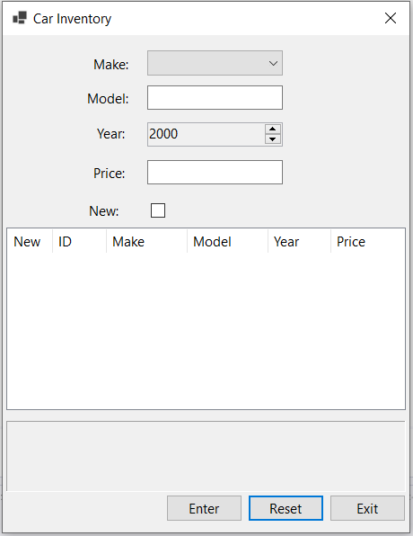

* Application after reset.

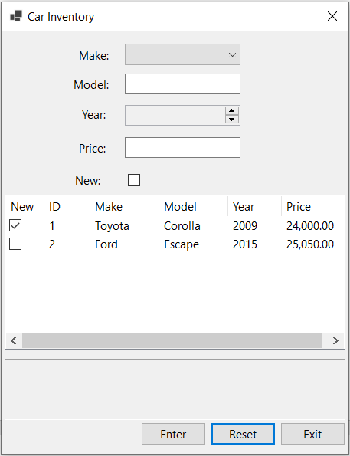

* Enter first set of valid data.

|  |  |  |  |  |  |  |  |
| --- | --- | --- | --- | --- | --- | --- | --- |
| Car Inventory | | | | | | |  |
| Make: Toyota  Model: Corolla  Year: 2009  Price: 24000  New: New | | | | | | |
| New | ID | Make | Model | Year | | Price |
| New | 1 | Toyota | Corolla | 2009 | | 24000.00 |
|  | | | | | | |
|  | | | | | | |
| Enter | | | Reset | | Exit | |  |

* Enter second set of valid data.

|  |  |  |  |  |  |  |  |
| --- | --- | --- | --- | --- | --- | --- | --- |
| Car Inventory | | | | | | |  |
| Make: Ford  Model: Escape  Year: 2015  Price: 25050  New: Used | | | | | | |
| New | ID | Make | Model | Year | | Price |
| New | 1 | Toyota | Corolla | 2009 | | 24000.00 |
| Used | 2 | Ford | Escape | 2015 | | 25050.00 |
|  | | | | | | |
|  | | | | | | |
| Enter | | | Reset | | Exit | |  |

* Select one item from the list view.

|  |  |  |  |  |  |  |  |
| --- | --- | --- | --- | --- | --- | --- | --- |
| Car Inventory | | | | | | |  |
| Make: Toyota  Model:  Year: 2010  Price: ten thousand  New: New | | | | | | |
| New | ID | Make | Model | Year | | Price |
| New | 1 | Toyota | Corolla | 2009 | | 24000.00 |
| Used | 2 | Ford | Escape | 2015 | | 25050.00 |
|  | | | | | | |
| Enter | | | Reset | | Exit | |  |

* Enter some invalid data.

|  |  |  |  |  |  |  |  |
| --- | --- | --- | --- | --- | --- | --- | --- |
| Car Inventory | | | | | | |  |
| Make:  Model:  Year: 2010  Price:  New: New | | | | | | |
| New | ID | Make | Model | Year | | Price |
| New | 1 | Toyota | Corolla | 2009 | | 24000.00 |
| Used | 2 | Ford | Escape | 2015 | | 25050.00 |
| You must select a make.  You must enter a model.  You must enter the price as a number. | | | | | | |
| Enter | | | Reset | | Exit | |  |

* Enter some invalid data.

|  |  |  |  |  |  |  |  |
| --- | --- | --- | --- | --- | --- | --- | --- |
| Car Inventory | | | | | | |  |
| Make: Toyota  Model:  Year: 2010  Price: ten thousand  New: New | | | | | | |
| New | ID | Make | Model | Year | | Price |
| New | 1 | Toyota | Corolla | 2009 | | 24000.00 |
| Used | 2 | Ford | Escape | 2015 | | 25050.00 |
| You must enter a model.  You must enter the price as a number. | | | | | | |
| Enter | | | Reset | | Exit | |  |